Product Mix (PMIX) Analysis

SOP

Executive Summary
The Product Mix PMIX Analysis process is used to understand how each menu item is performing in terms of sales and profit. It combines sales data from Toast and cost data from Restaurant365 to calculate the true cost and profit of every item.
The process starts by downloading three reports: Raw Menu Breakdown, Raw Modifiers, and Modifier Costs. These reports are cleaned and organized in the PMIX Google Sheets file. Modifier costs are added to each item so we can calculate the correct total average cost, including bases, mains, veggies, sauces, toppings, and other add-ons.
After calculating the final cost for each item, the master sheets show key numbers such as average price, quantity sold, total sales, total cost, margin, food cost percentage, and menu mix percentage. Based on these numbers, items are grouped into four categories: Star, Plow Horse, Puzzle, and Dog.
Separate sheets are created for each revenue center such as Inhouse, 3PD, and THANX. A blended sheet then combines all channels to show the overall company performance using weighted averages.
Overall, the PMIX process helps the company understand what items are selling, how much profit they make, and where changes are needed to improve margins and overall performance.

Objective

To analyze the sales and profitability performance of individual products (menu items) within a defined period to support informed business decisions. It helps to understand what items are selling, how much profit they’re generating and where improvements are needed.

Platforms Used:

Platform | Purpose
Restaurant365 | Fetch average costs and modifier costs
Toast | Fetch Raw Menu Breakdown and Raw Modifiers
Google Sheets (PMIX Analysis File) | Main reporting document
Bikky | Extraction of Item level customer retention and return rate

Sheet Sections
- Raw Menu Breakdown, Raw Modifiers, Modifier Costs, Lookup Menu Breakdown, Lookup Items and Modifier types
- Clean Menu Breakdown, Clean Modifiers, Pivot Menu Breakdown with Cost
- Item level sheets with pivots for each modifier type
- Menu item master sheets for - overall, inhouse, 3PD, Loyalty and blended sheet.

Fetching Data

Systems - Restaurant365, Toast
Number of reports fetched - 3
Name of reports fetched - Raw Menu Breakdown, Raw Modifiers, Modifier costs

- Raw Menu Breakdown
- Fetched from toast
STEPS:
- Login to Toast
- Go to Reports on the right menu
- Under Menus select Menu Breakdown
- Make the following selections from the drop down menu
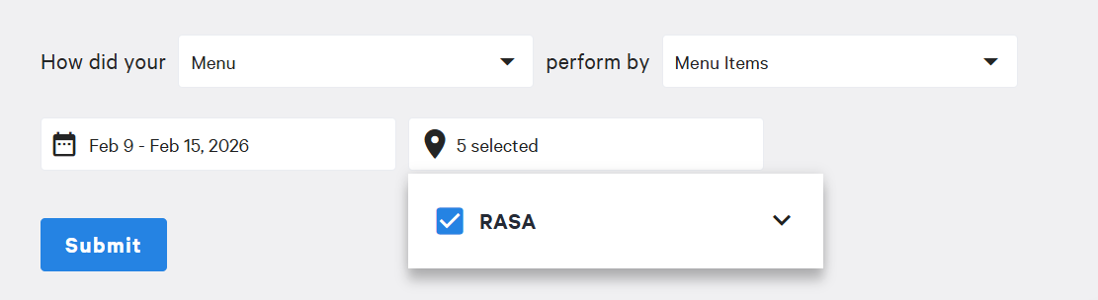
- Scroll and download the report
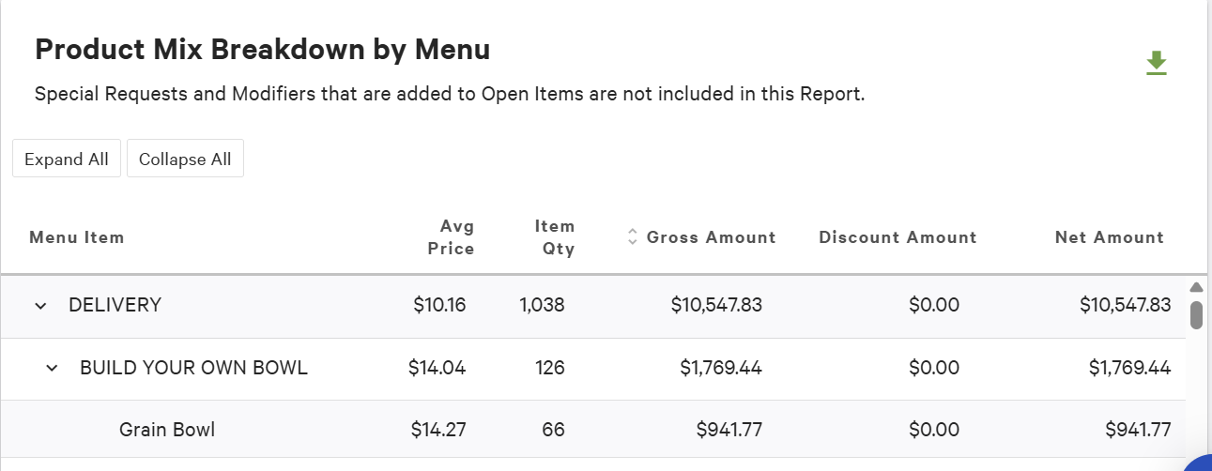

- Raw Modifiers
- On the same page at Toast, under Menus, and Menu Breakdown make the following selection and click on submit
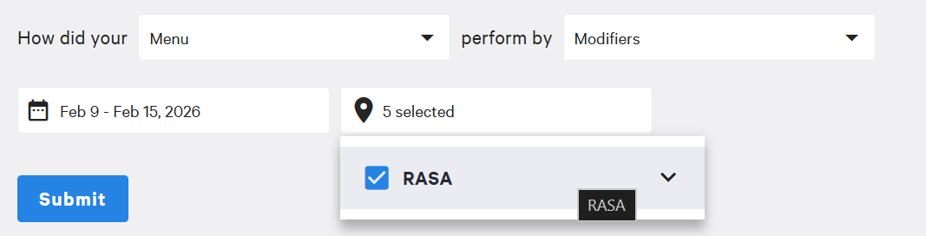
- Scroll and download the report
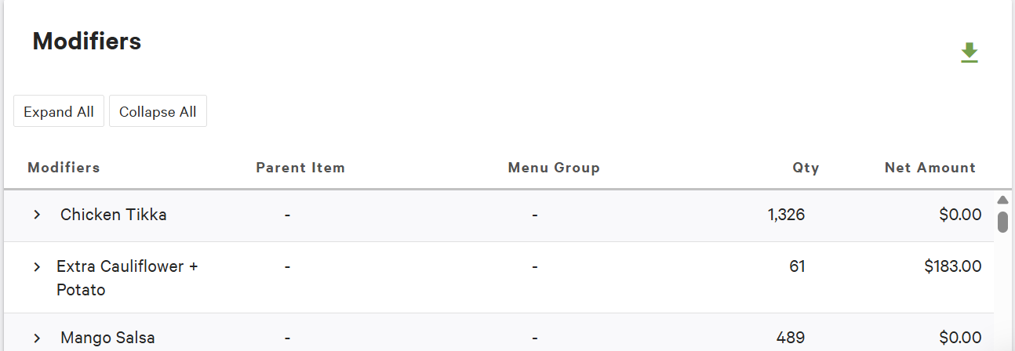

- Modifier Costs
- Login to rasa.restaurant365.com
- Go to reports on the sidebar and click on My Reports
- Select CUSTOMIZE on Recipes section and select the following and then click RUN:
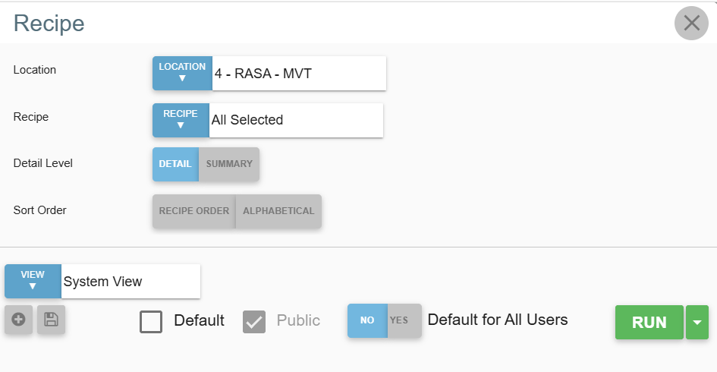
- Now export the file in .csv format using the save option on the top of the report

Cleaning the Data

After exporting the raw modifiers, raw menu breakdown and modifier costs sheets, create new cleaned sheets named : Clean Menu breakdown, Clean Modifiers
NOTE - SHEETS LOOKUP MENU BREAKDOWN AND LOOKUP ITEM AND MODIFIER TYPES ARE USED TO TAKE AS A REFERENCE TO CLEAN THE DATA FROM RAW DUMP. IF ANY #NA APPEARS IN THE CLEAN SHEETS WE BACKTRACK AND ADD THE MENU ITEM/MODIFIERS IN THE LOOKUP SHEETS FIRST.

- Clean Menu Breakdown
- Copy the data from raw menu breakdown and create a filter and deselect the blank items.

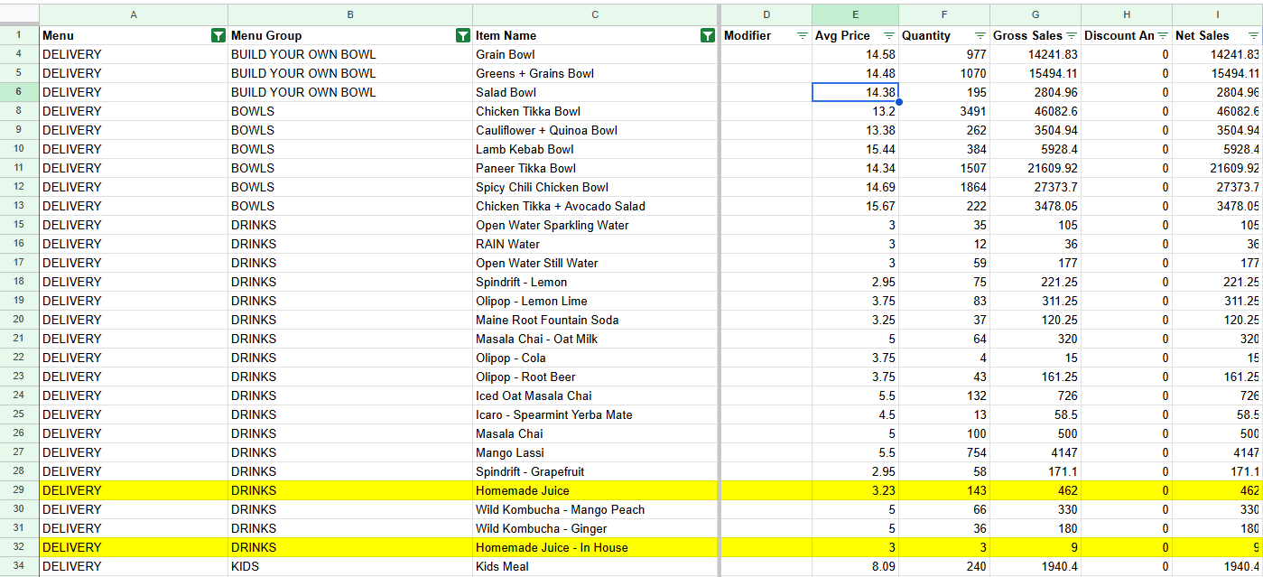
- Add the following columns to this sheet : Item name_updated, Category 1 and Category 2 that are referenced from Lookup menu breakdown sheet.
- After that add the following columns :
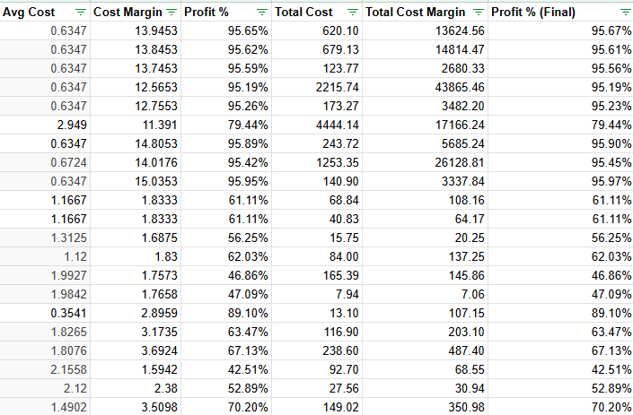
NOTE : AVG COST IS INPUTTED MANUALLY FROM R365 FOR EACH ITEM.
COST MARGIN = AVG PRICE - AVG COST

PROFIT% = COST MARGIN / AVG PRICE
TOTAL COST = AVG COST * QUANTITY
TOTAL COST MARGIN = TOTAL COST / QUANTITY
PROFIT% FINAL = TOTAL COST MARGIN / NET SALES

Also from the menu column change all the APP, Online Ordering line items to Loyalty. Since we consider them into the Loyalty category.

NOTE : COPY THE MENU COLUMN AND PASTE IT IN A NEW COLUMN FOR REFERANCE.

- Clean Modifiers
- Copy the raw modifier sheet and add item type, concat and modifier type new columns.
- Item type and Modifier type new columns are referenced from lookup item and modifier sheet.
- Concat column should contain the concatenation of modifiers and item type column values
- Create a filter on the sheet and remove blank items.
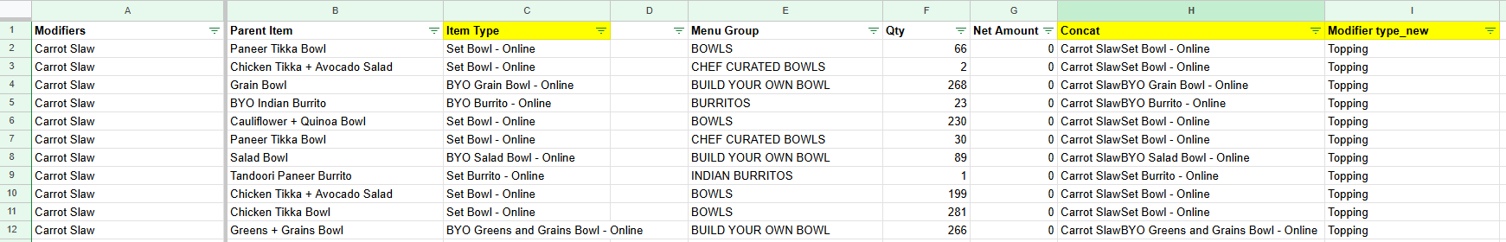

- Pivot Menu Breakdown with cost
- Create pivot tables for all categories of menu items and their avg costs along with separate pivots for their channel : Inhouse, 3PD and LOYALTY (Online + APP).
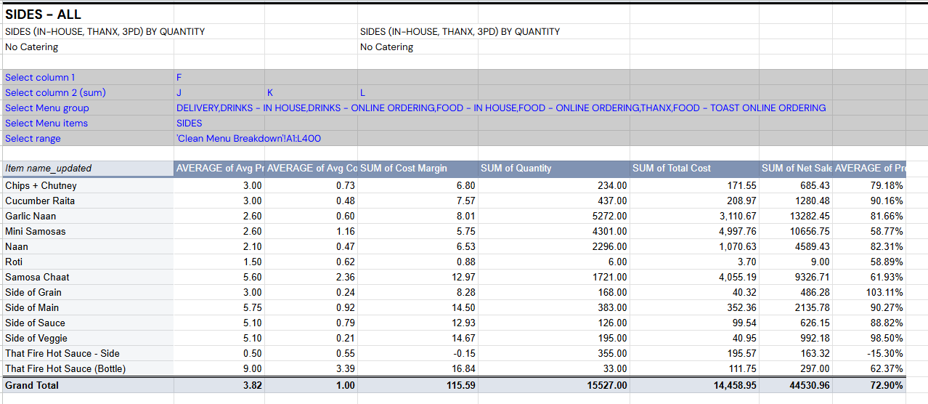
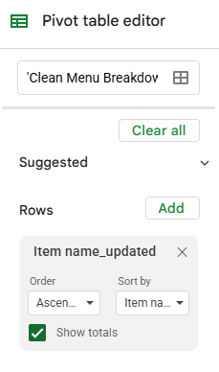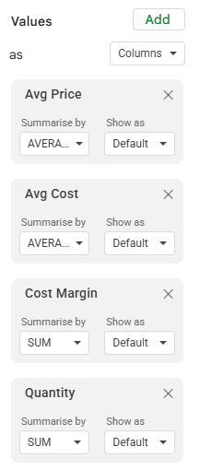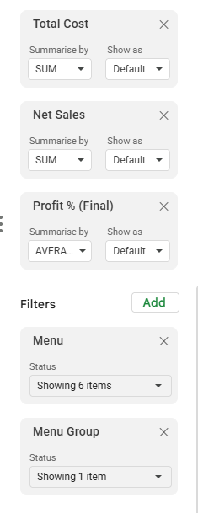

ITEM LEVEL ANALYSIS

These sheets are used to analyse the modifier costs for every item with pivot tables made for all modifier types and then the total average cost with modifiers is calculated and updated using reference under average cost with modifiers column of the Menu Item Master with Cost - Overall sheet.

These pivot tables are made using the Clean Modifiers sheet.

Cost for these items are fetched from modifier costs sheets using the VLOOKUP Function.

The modifier types are : Bases, Mains, Extra Mains, Veggies, Extra Veggies, Toppings, Sauces, Chutney and Dressings, Make it a Meal (includes sides, drinks and sweets).

- Bases :

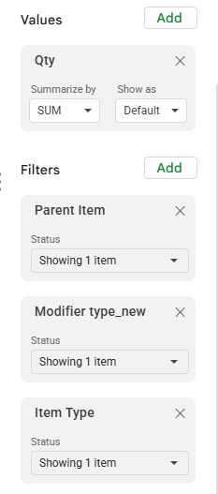
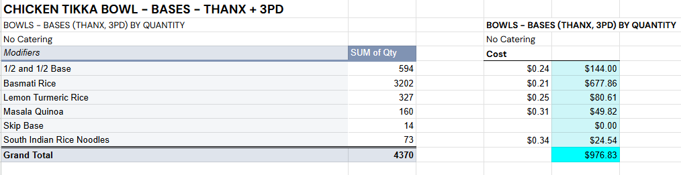
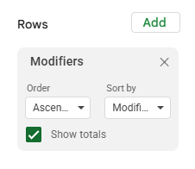

NOTE : for ½ Bases, cost is calculated using a separate pivot attached below and weighted average is calculated relative to the total quantity of the ½ bases in the menu item.

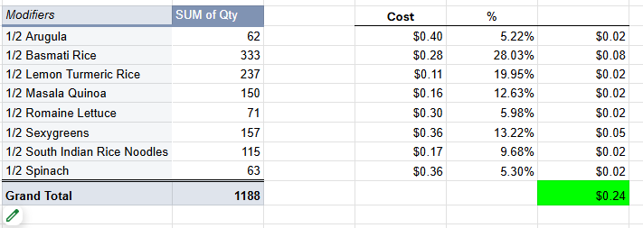

Here, % values are calculated using: values of sum of qty for ½ item / total
The third column is the product of the calculated % values and cost values.

- Mains :

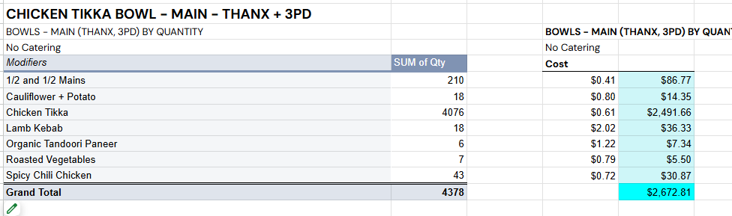

Use same pivot table values and filters, change the modifier type to mains.

NOTE - for items that are Plates, Mains are not included in the total modifier cost.

Use similar methodology as ½ bases for ½ mains as well by creating a separate pivot for them.

- Extra Mains

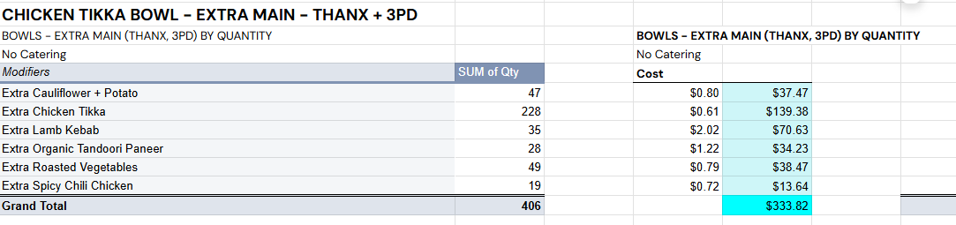

- Veggies

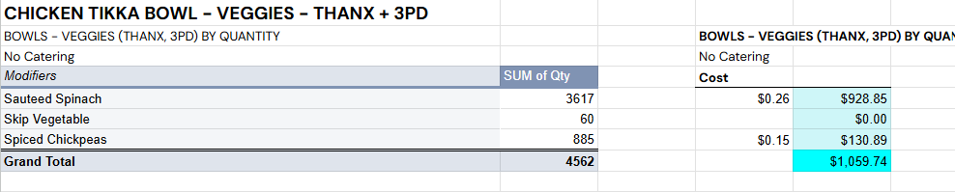

- Extra Veggies

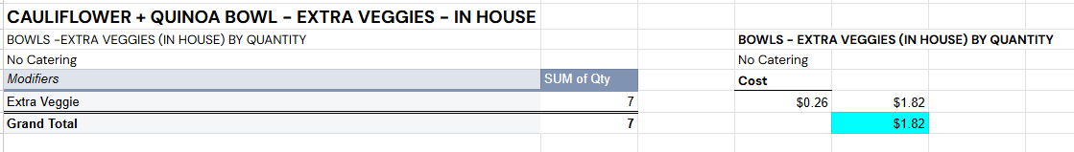

- Sauce

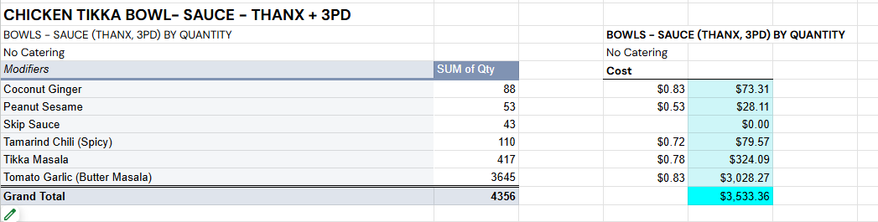

- Chutney and Dressings

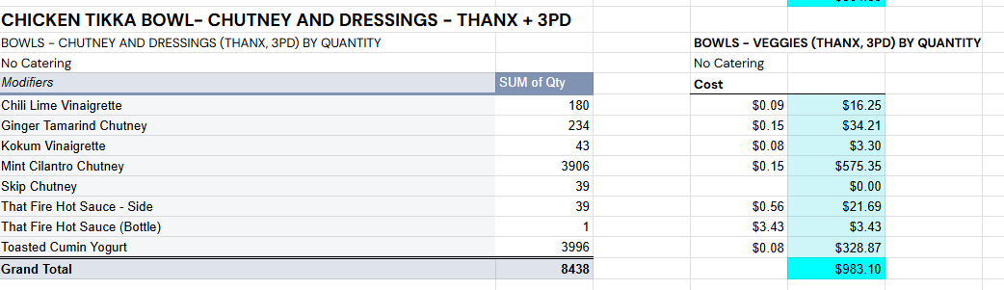

- Toppings

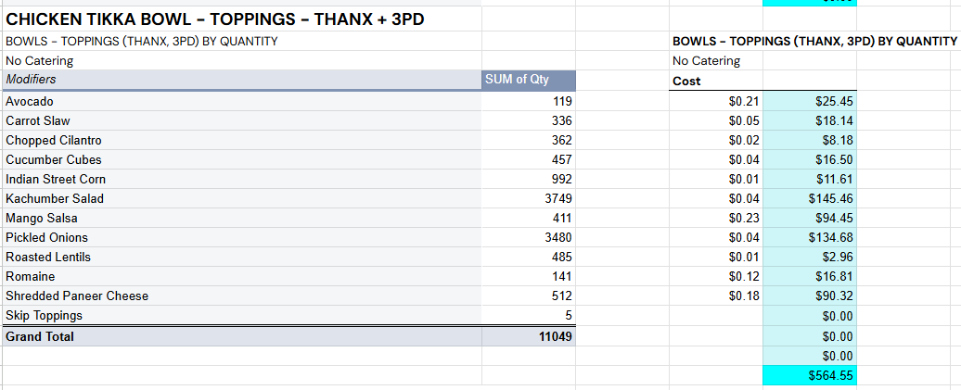

- Make it a Meal - sides, drinks, sweets

Select sides, drinks and sweets under modifier types for this.

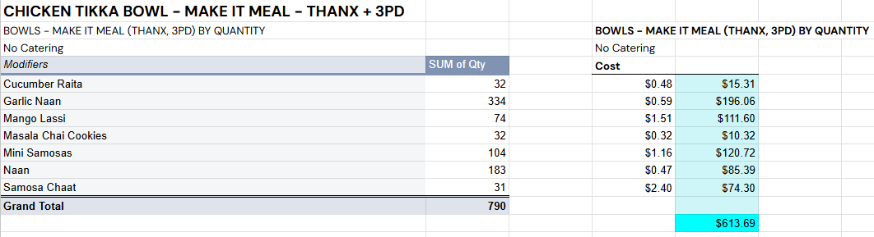

FINAL ITEM ANALYSIS

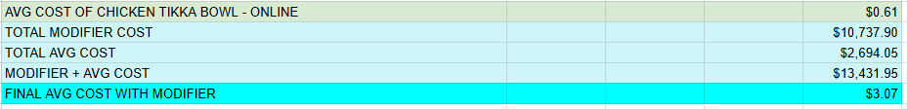

Total modifier cost is the sum of all the previous total modifier type costs calculated in the pivot tables.
Total average cost is calculated as average cost / quantity referenced from menu item master with costs overall sheets.
Final avg cost is the division of modifier + avg cost with the quantity referenced from menu item mast with costs overall sheets.

The final cost is then updated as a reference to the menu item master with cost overall sheet under the average cost with modifiers column.

MASTER SHEETS
These sheets are used to display the final profitability analysis and classification of items into different categories based on their menu mix and margins.

The categories are as follows : DOG - LOW MARGIN LOW PROFIT
STAR - HIGH PROFIT HIGH MARGIN
PUZZLE - HIGH MARGIN LOW MIX
PLOW HORSE - LOW MARGIN HIGH MIX

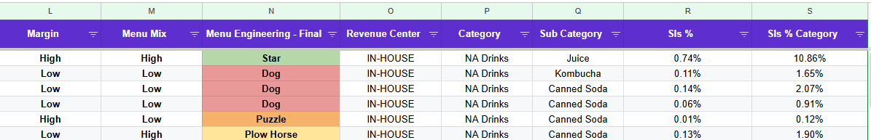

Avg Price : referenced from pivot menu breakdown with cost by matching their revenue centre to the pivot sheet.

Avg cost with Modifiers : referenced from the item level pivot sheets and clean menu breakdown.
NOTE : AVERAGE COST 3PD = AVERAGE COST WITH MODIFIER ONLINE*1.18

Margin = Avg Price - Avg cost with Modifiers

Quantity : referenced from pivot menu breakdown with cost by matching their revenue centre to the pivot sheet.

Total Cost = Avg cost with modifiers * quantity

Net Sales = Avg price * quantity

Total Margin = Net sales - Total Cost

COGS% = Total cost / Net sales

% Margin = Margin / Avg Price

%Menu Mix = Item quantity / sum of all quantities

The second margins and menu mix columns are the classifications of the item on the basis of their overall performance into HIGH and LOW classes.

SLS% = Net sales / sum of net sales

NOTE : After the overall sheets, separate sheets need to be made for all revenue centres, i.e. Inhouse, 3PD and THANX.

MASTER ITEMS WITH COST SHEETS BLENDED

This sheet contains the weighted average of all revenue centres for all the sheet values.
FORMULA USED : =ARRAYFORMULA( QUERY( {A2:C, B2:B*C2:C}, "select Col1, sum(Col4)/sum(Col3) where Col1 is not null group by Col1 label sum(Col4)/sum(Col3) ''", 0 ) )

